**CS 6360.004/005 - Assignment 4**

Due Date: November 9, 2015

**1.** Are the following sets of FDs equivalent? Explain why.

{A->C, AC->D, E->AD, EC->DH, DE->CH }

{A->CD, E->AH}

Solution:

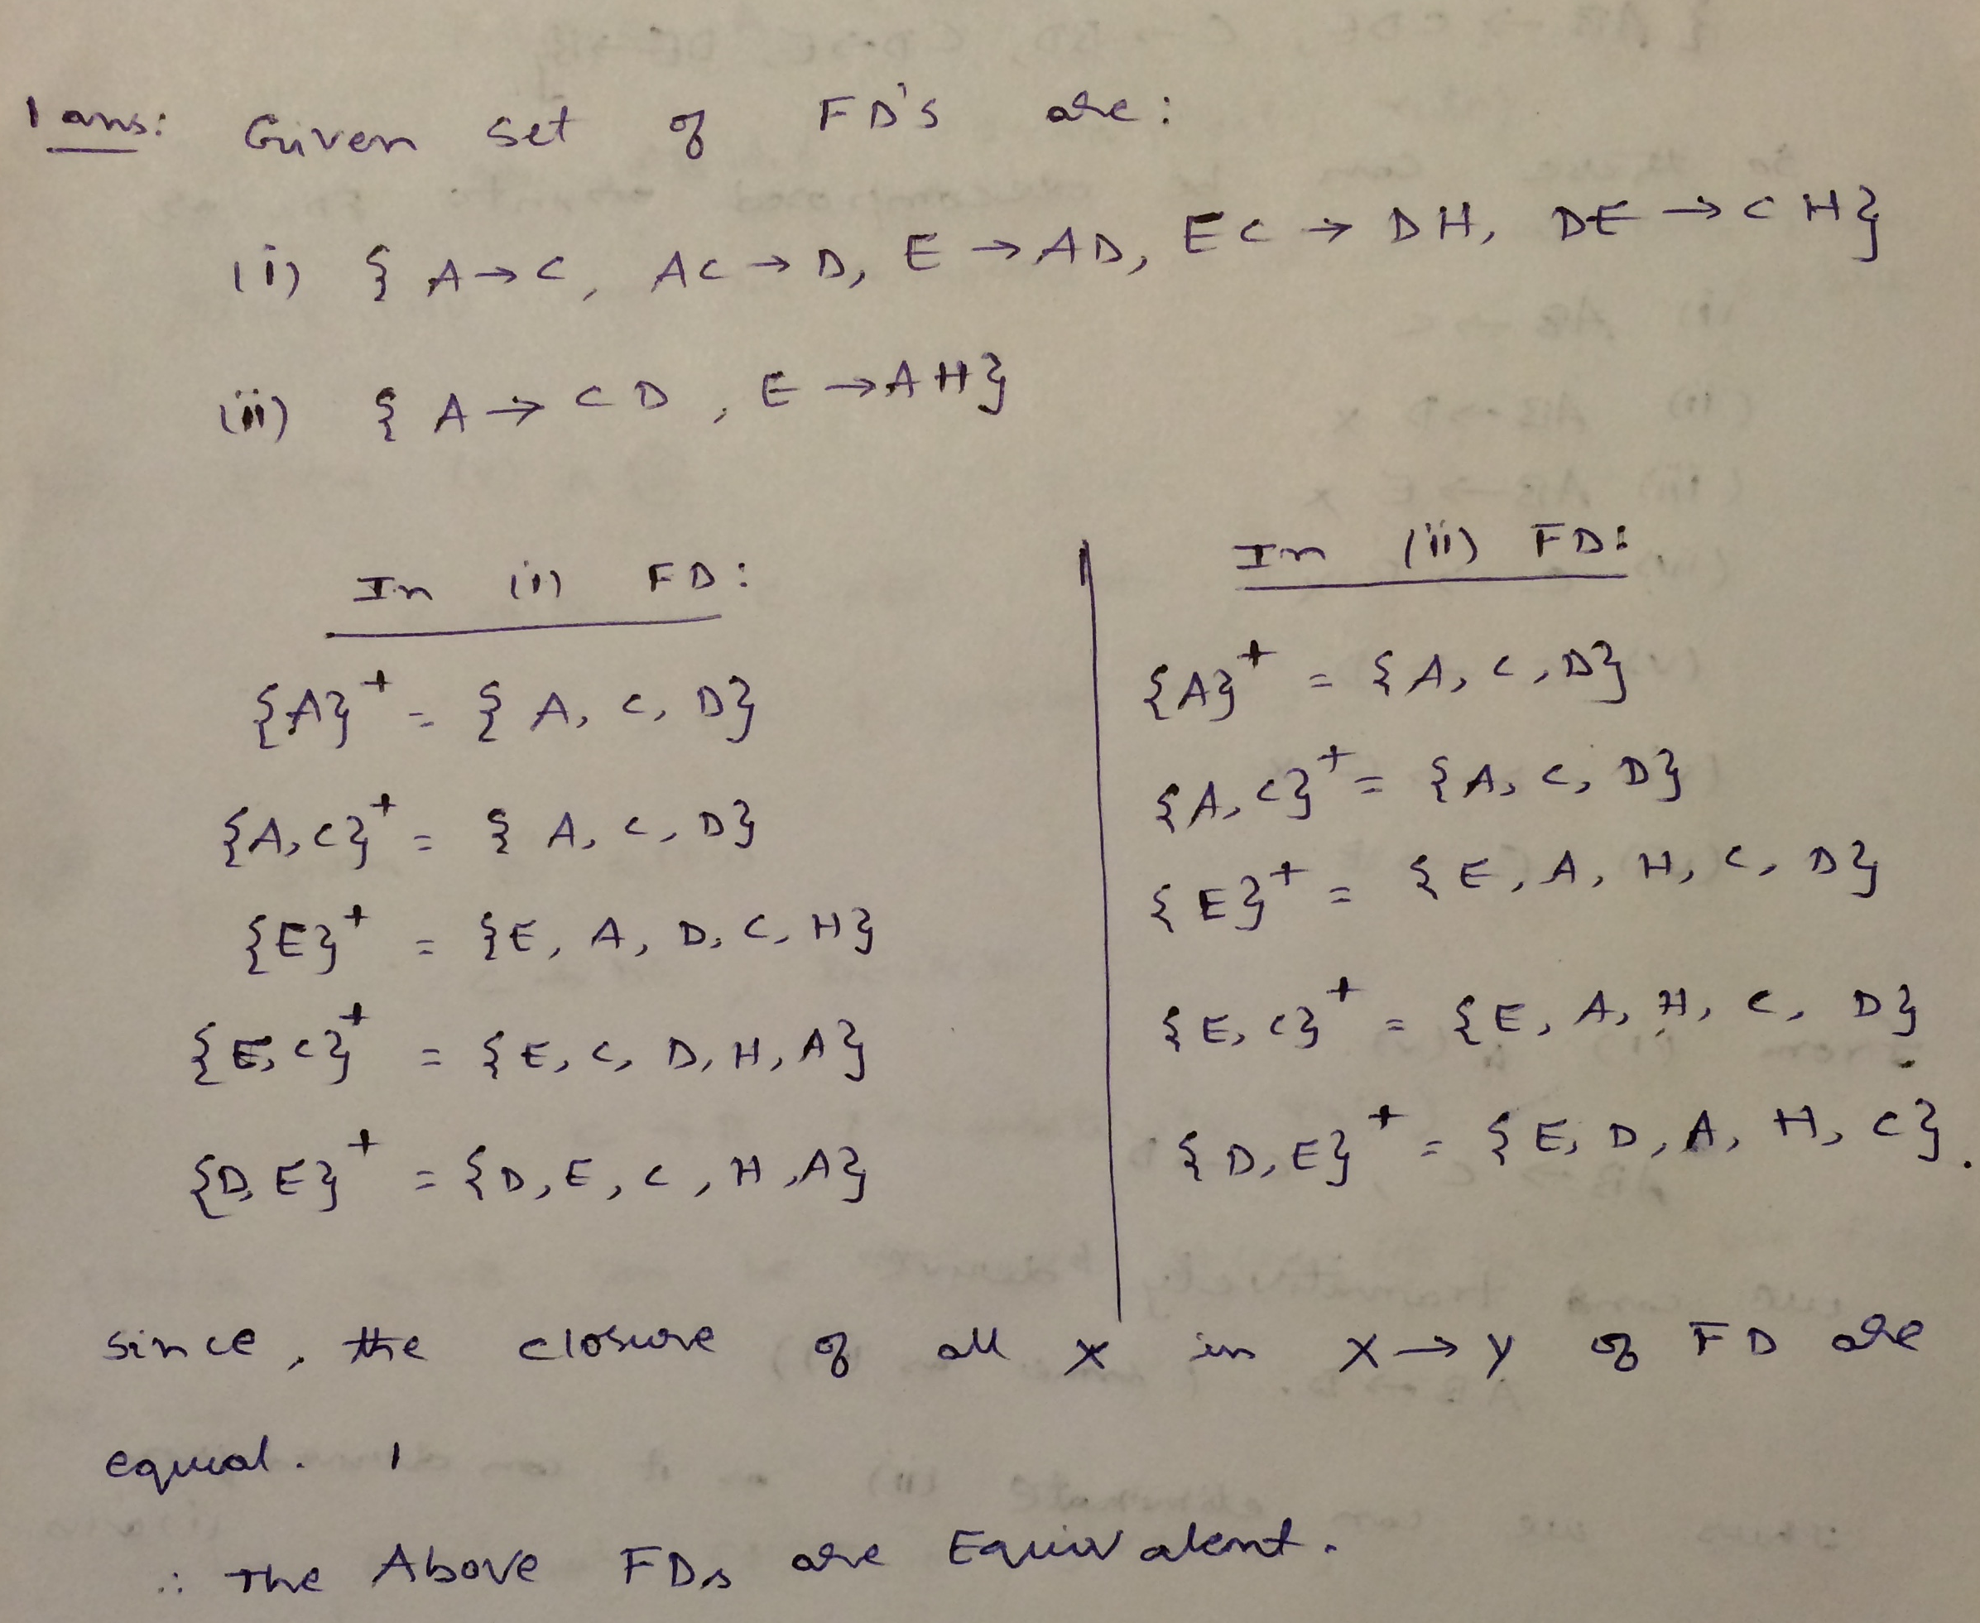

**2.** Find a 3NF decomposition of a relation R(ABCDEFGHIJ) that satisfies the following FDs: { AB->C, BD->EF, AD->GH, A->I, H->J, GD->ABH }

Solution:

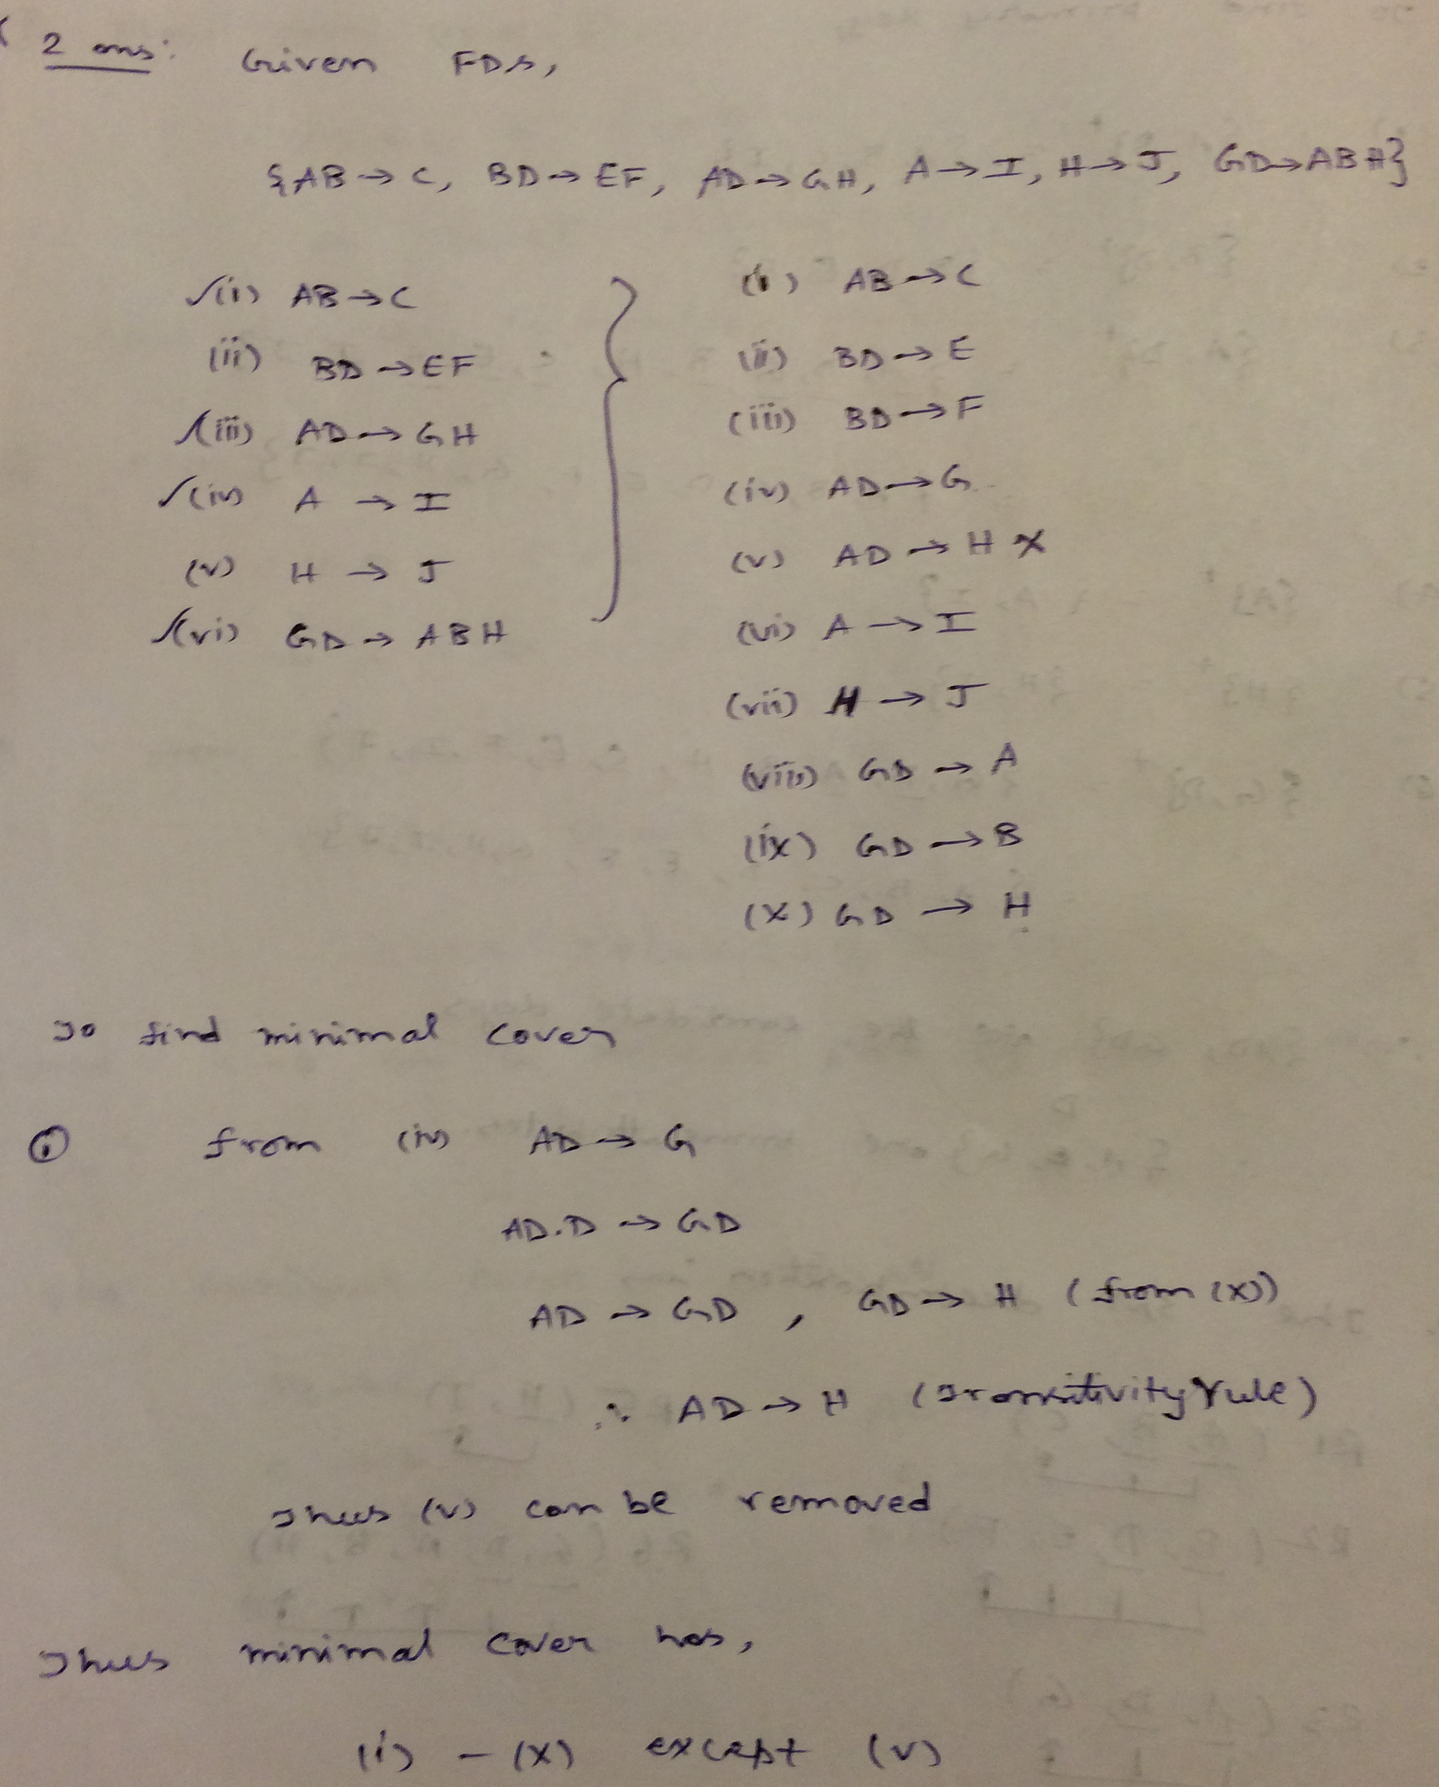

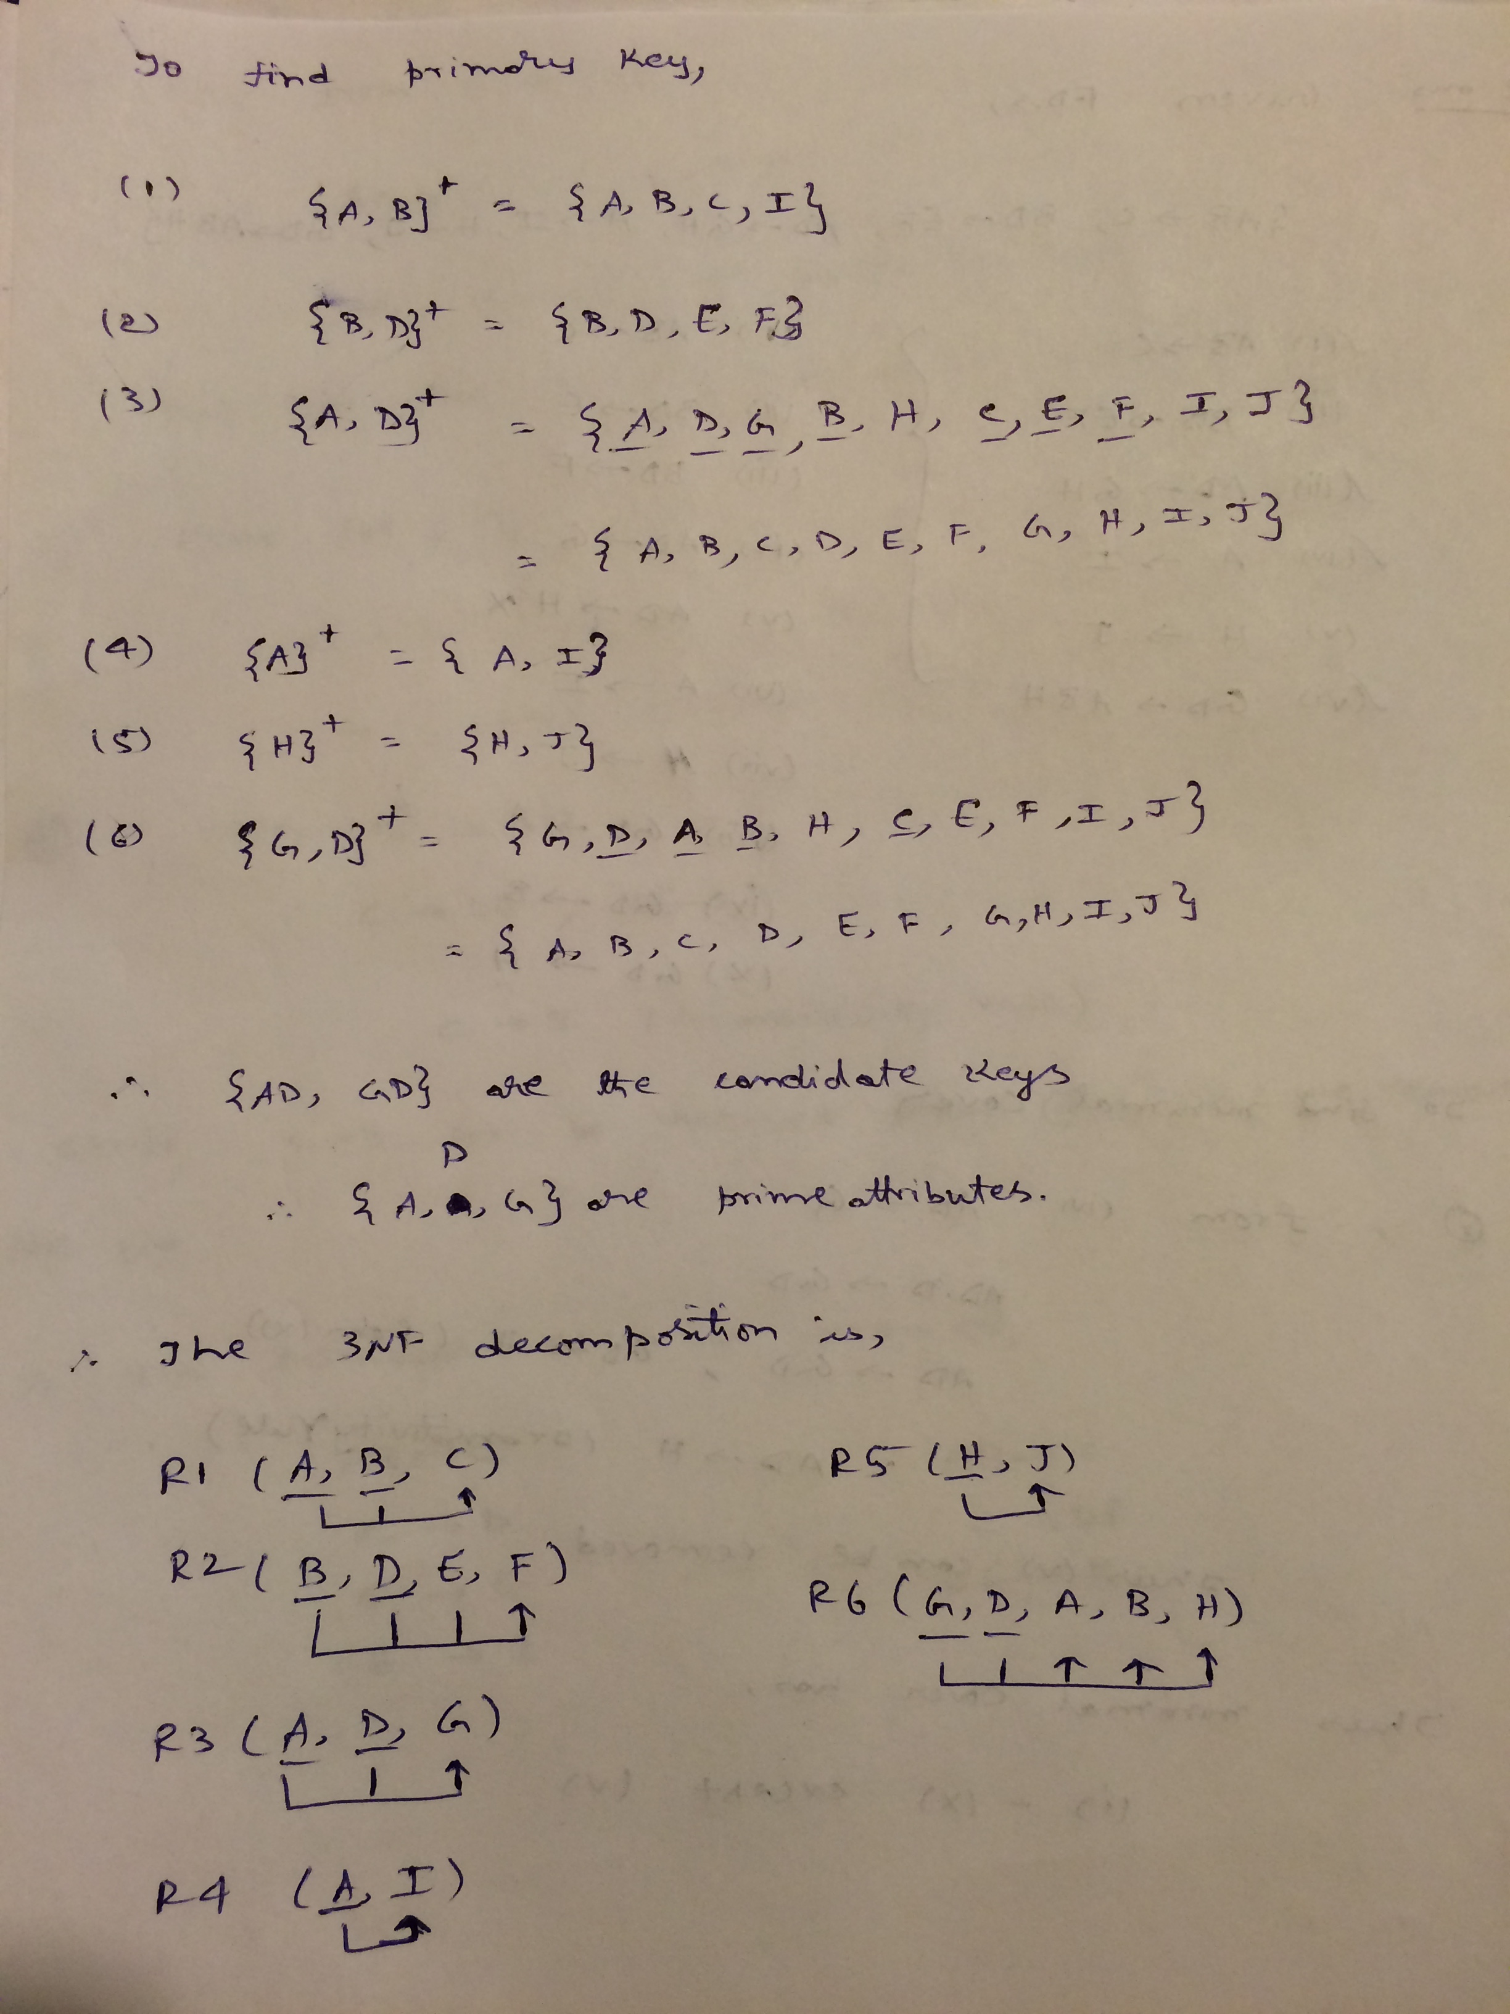

**3.** Find a minimal cover of the following set of dependencies:

{AB->CDE, C->BD, CD-> E, DE->B }

Solution:

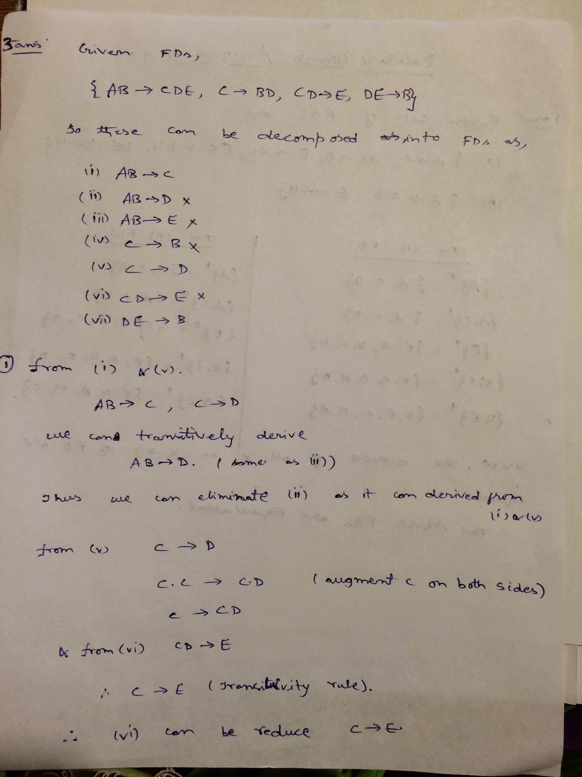

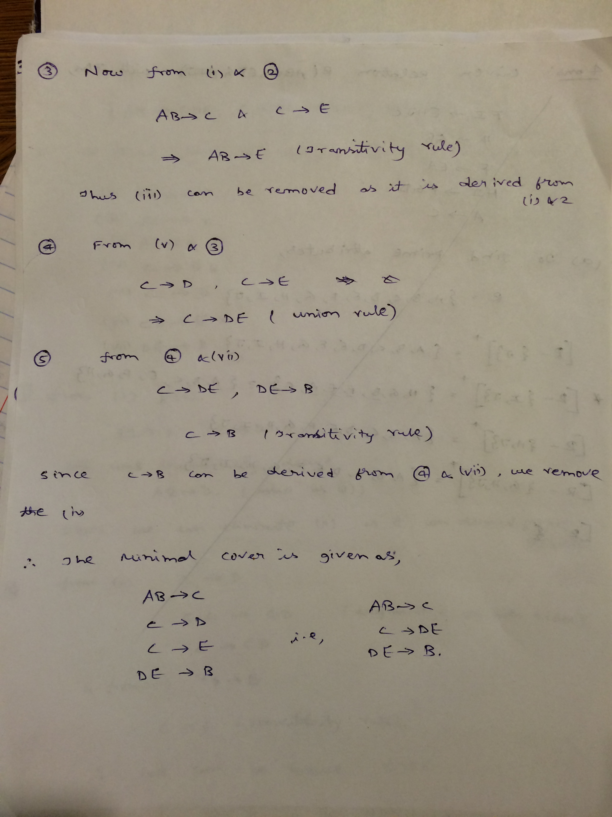

**4.** Consider a relation R(ABCDEFGHIJ) satisfying the following FDs: FI→EHJC H→GB F→EA HI→FGD A→C

(a) Find the list of all prime attributes of R. Show the steps.

(b) Based on given functional dependencies and candidate keys that you have found, find a 3NF decomposition of R.

Solution:

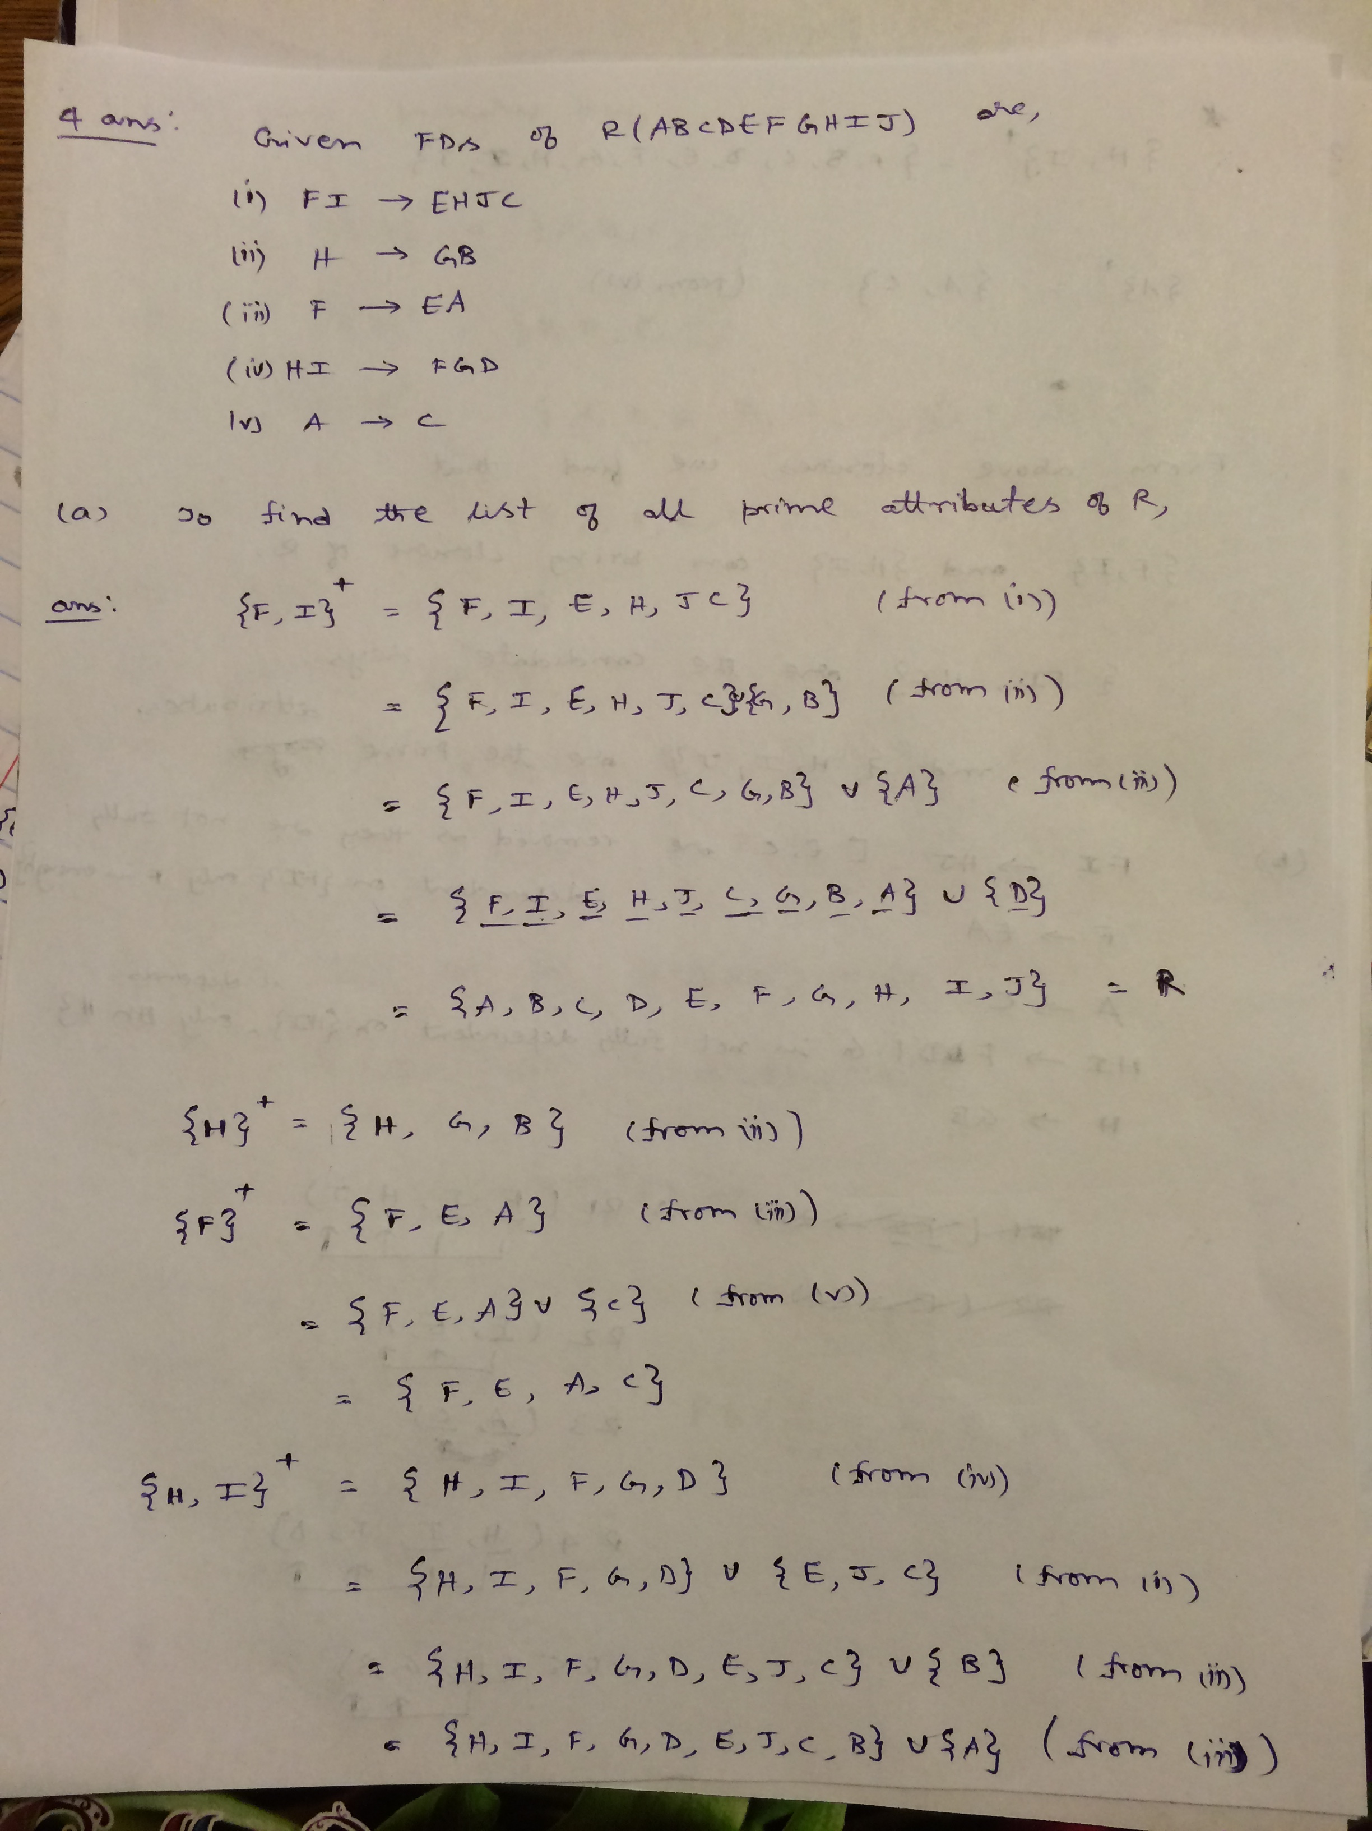

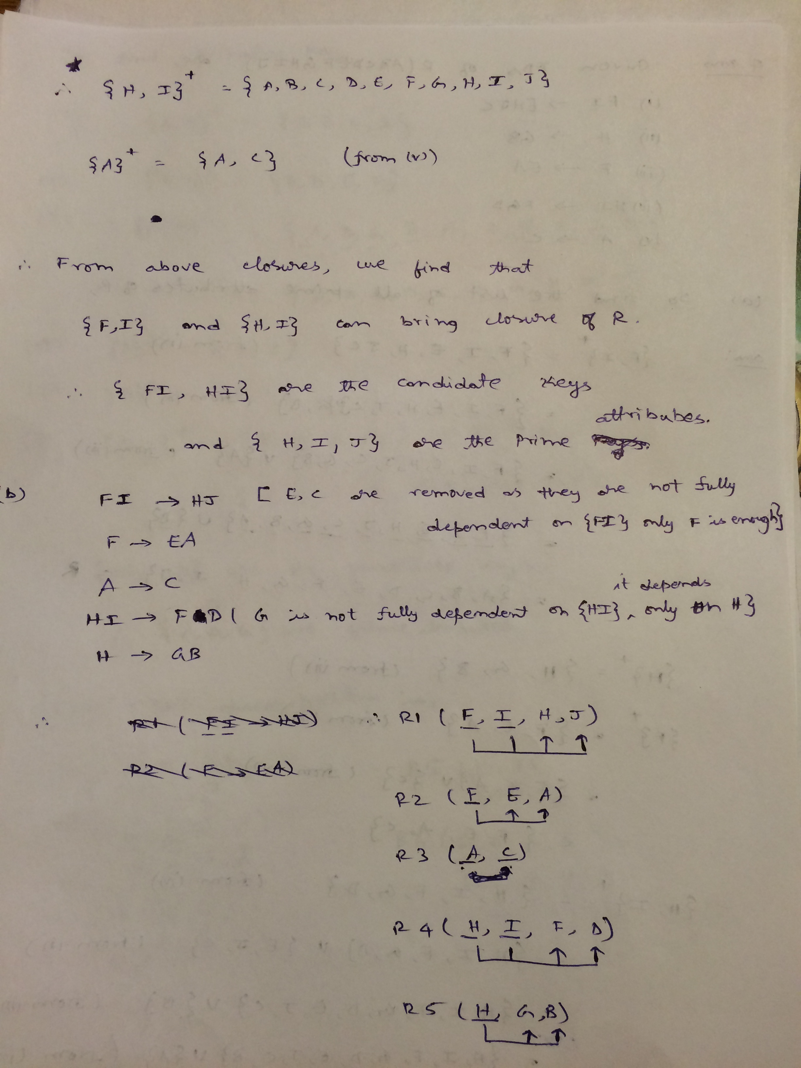

**5.** Find a lossless (non-additive), dependency preserving 3NF decomposition of R(EFGHI) using the minimal cover method. R satisfies the following dependencies:

FG→E HI→E F→G FE→H H→I

Solution:

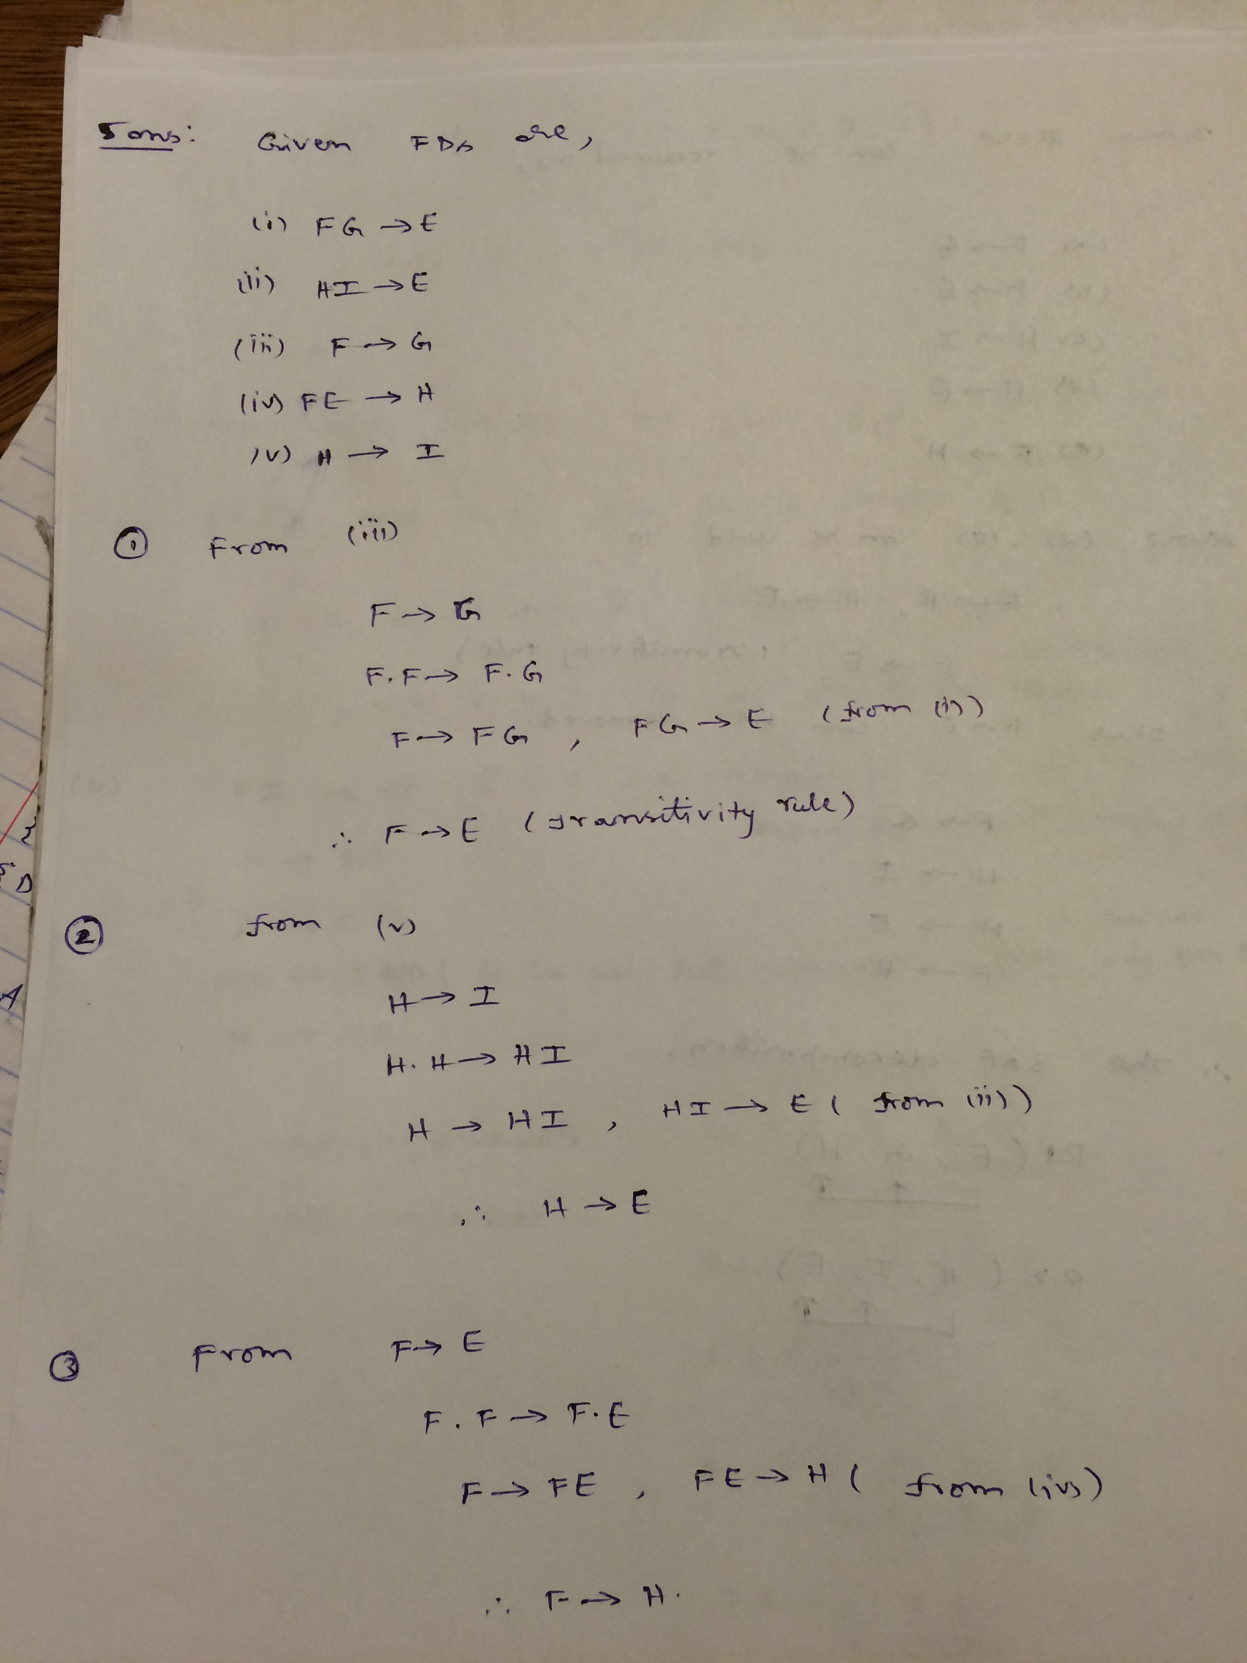

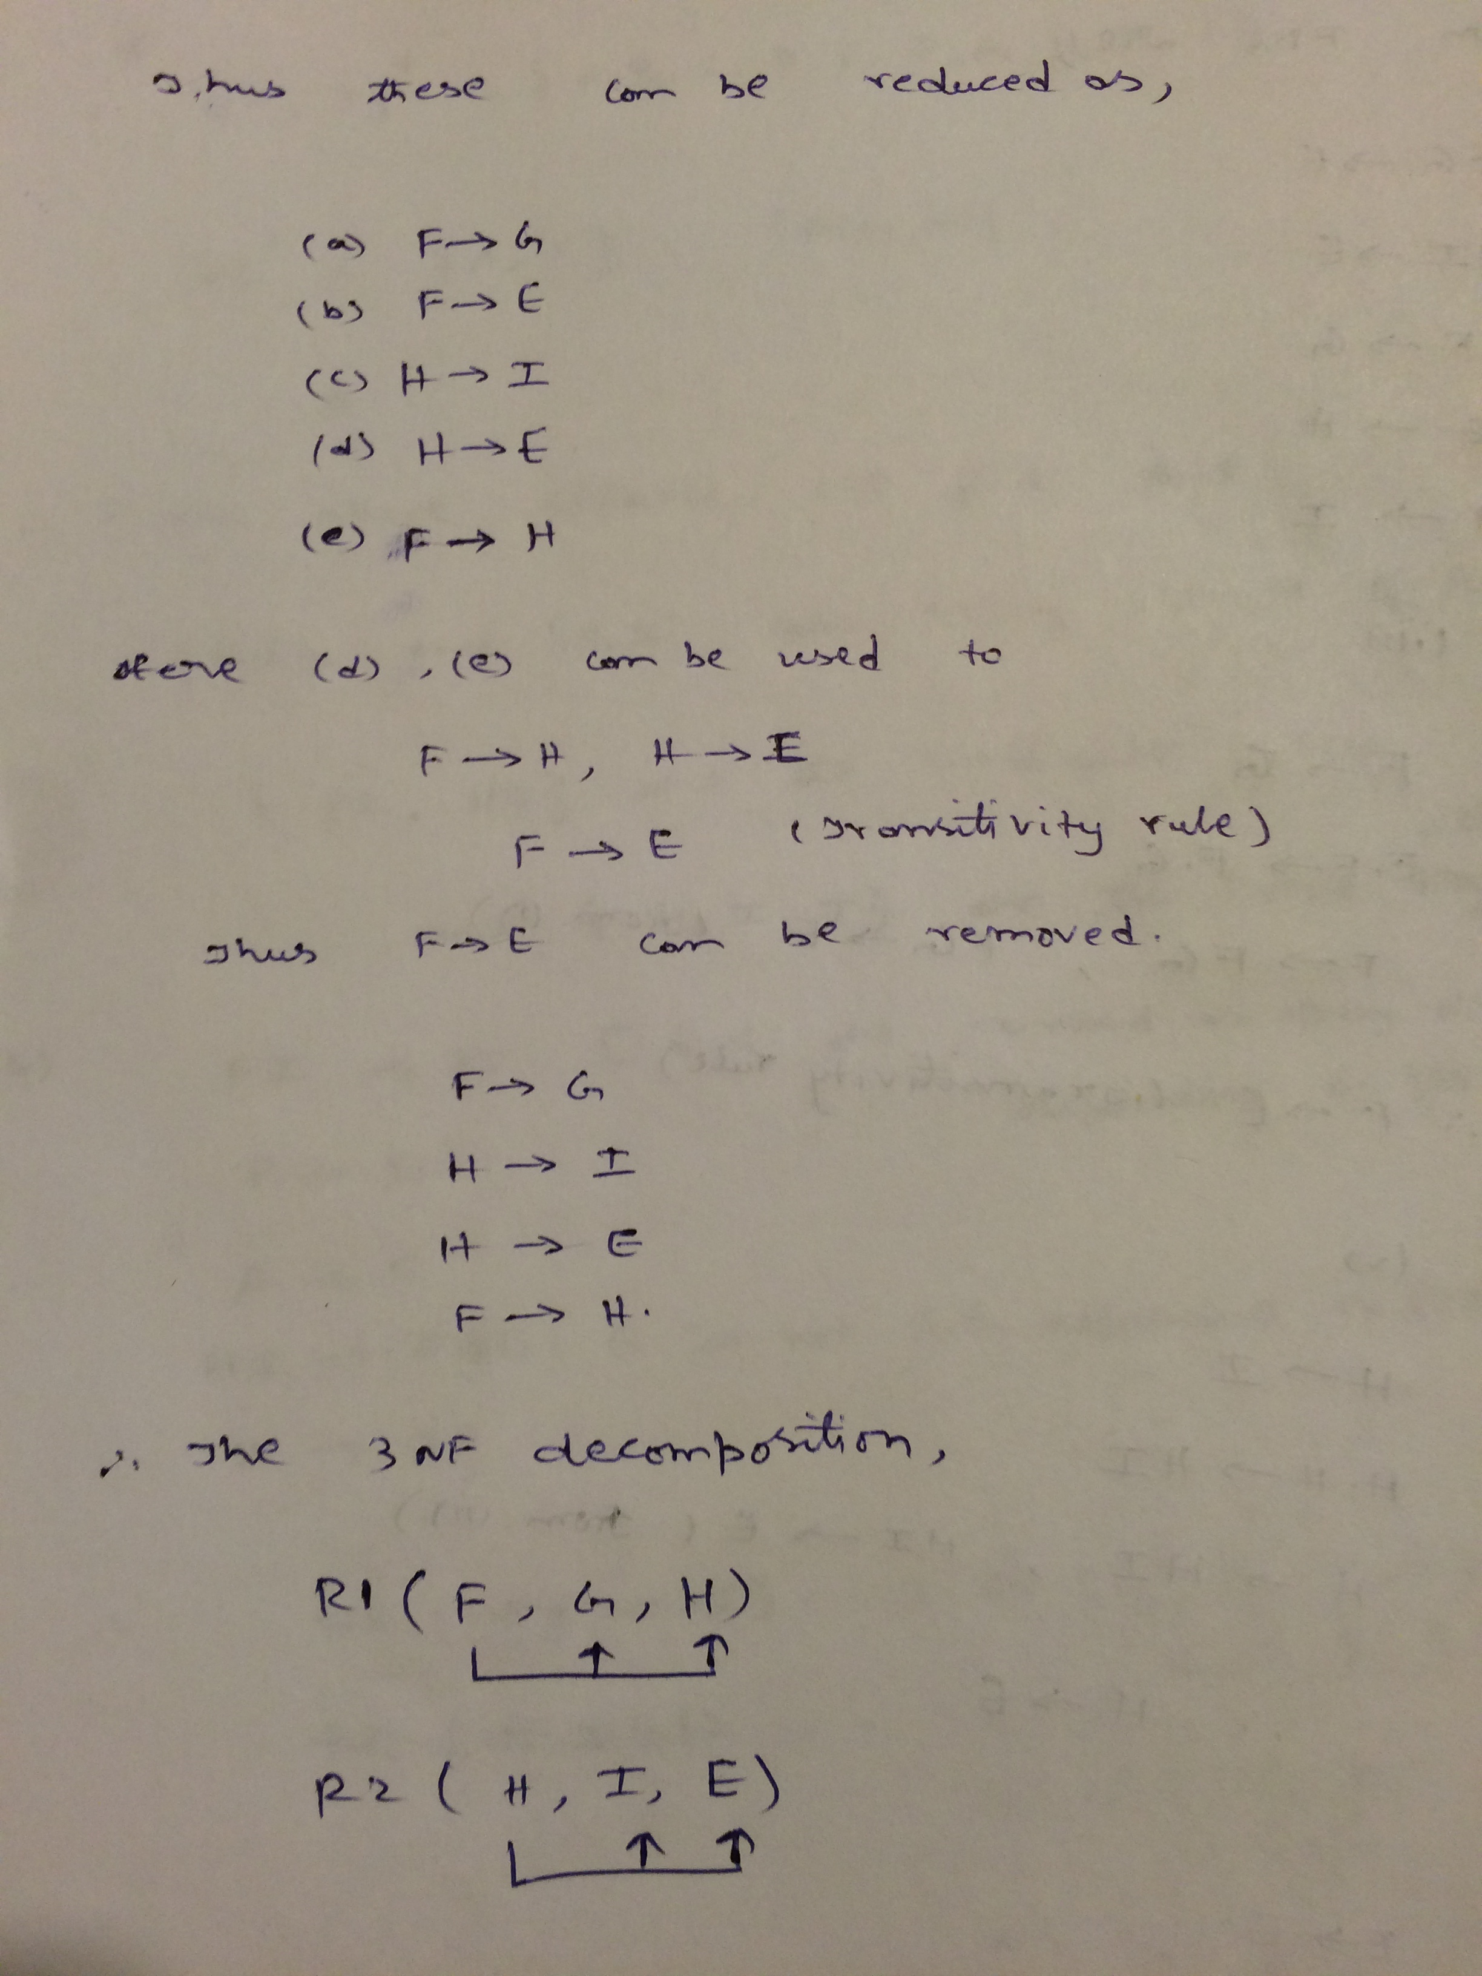

**6.** Write a PL/SQL program that raises the salary of the employees in ‘Sales’ department by 25%.

Solution:

**PL/SQL Program:**

set serveroutput on

DECLARE

thisEmployee Employee%ROWTYPE;

oldSalary Employee.salary%TYPE;

newSalary Employee.salary%TYPE;

CURSOR SalesEmployees IS

SELECT * FROM Employee WHERE DNO IN

(SELECT Department.DNO FROM Department WHERE Dname = 'Sales');

FOR UPDATE;

BEGIN

OPEN SalesEmployees;

LOOP

FETCH SalesEmployees INTO thisEmployee;

EXIT WHEN (SalesEmployees%NOTFOUND);

oldSalary:=thisEmployee.salary;

newSalary:=oldSalary*1.25;

UPDATE Employee SET salary = newSalary

WHERE CURRENT OF SalesEmployees;

END LOOP;

CLOSE SalesEmployees;

END;

.

RUN;

**7.** Write a stored procedure in PL/SQL that prints out the list of books that have been borrowed from a particular branch in last 30 days and haven’t been returned yet. Procedure should accept the Branch-name as an input parameter. Along with the book title, display also the borrower’s name and phone number.

**7 Solution:**

**Procedure creation:**

create or replace procedure BorrowedLast30Days(bname IN VARCHAR) AS

thisBookLoan Book_loans%ROWTYPE;

thisBookName BOOK.TITLE%TYPE;

thisBorrowerName borrower.name%TYPE;

thisBorrowerPno borrower.phone%TYPE;

z number;

CURSOR AllBookloans IS

SELECT * FROM Book_loans

where Return_date is null AND Branch_id IN

(SELECT Branch_id FROM Library_branch where branch_name=bname);

BEGIN

dbms_output.put_line('bname:= '|| bname);

OPEN AllBookloans;

LOOP

FETCH AllBookloans INTO thisBookloan;

EXIT WHEN (AllBookloans%NOTFOUND);

Z:=FLOOR(SYSDATE-thisBookloan.date_out);

IF Z<31 THEN

select title into thisBookName from book where BOOK_ID=thisBookloan.book_id;

select name into thisBorrowerName from borrower where card_no=thisBookloan.card_no;

select phone into thisBorrowerPno from borrower where card_no=thisBookloan.card_no;

dbms_output.put_line(' ');

dbms_output.put_line('Book Name : '|| thisBookName);

dbms_output.put_line('Borrower Name : '|| thisBorrowerName);

dbms_output.put_line('Borrower Phone Number : '|| thisBorrowerPno);

END IF;

END LOOP;

CLOSE AllBookloans;

END;

**PL/SQL code to run procedure:**

set serveroutput on

DECLARE

thisBranchName library_branch.branch_name%TYPE;

BEGIN

thisBranchName:='Dallas';

BorrowedLast30Days(thisBranchName);

END;

.

RUN;

Questions 1-5: 10 points, 6-7: 25 points